📘 Grade Management System – Project Documentation

1️.Project Overview

📌 Title:
Grade Management System (Java – Array Based Implementation)

🎯 Objective:
The objective of this project is to develop a console-based Grade Management System using Java that:
- Stores student names and marks using arrays
- Calculates student averages
- Assigns grades automatically
- Generates subject-wise reports
- Searches student records
- Displays grade distribution
- Validates input data
The system demonstrates fundamental concepts of:
- Arrays (1D and 2D)
- Methods
- Input validation
- Control statements
- Menu-driven programming
- Basic reporting logic

2️.Setup Instructions (Installation Guide)

🔹 Requirements:
- Java JDK 8 or higher
- Command Prompt / Terminal
- Optional: Any Java IDE (Eclipse, IntelliJ, VS Code)

🔹 Steps to Run

Step 1: Save the file as:
GradeManagementSystem.java

Step 2: Compile the program:
javac GradeManagementSystem.java

Step 3: Run the program:
java GradeManagementSystem
The console menu will appear.

3️.Code Structure Explanation

📌 Data Structures Used

1️. 1D Array
String[] studentNames;
Stores names of students.

2️.2D Array
double[][] studentMarks;
Stores marks of students for 5 subjects.
Structure:
studentMarks[studentIndex][subjectIndex]

📌 Constants Used
MAX_STUDENTS = 100
SUBJECT_COUNT = 5
Ensures fixed capacity and prevents overflow.

4️.Functional Modules

🔹 1. Add Student
- Accepts student name
- Accepts 5 subject marks
- Validates marks (0–100)
- Stores data in arrays

🔹 2. View Students
Displays:
- Name
- All subject marks
- Average

🔹 3. Calculate Averages
Calculates:
Average = Total Marks / Number of Subjects
Assigns grade using grading logic.

🔹 4. Find Top Performer
- Compares all averages
- Displays student with highest average

🔹 5. Generate Report
Displays:
- Total students
- Subject-wise averages
- Grade distribution

🔹 6. Search Student
- Case-insensitive name search
- Displays average and grade

5️.Grading System
Average | Grade
90+ | A+
80–89 | A
70–79 | B
60–69 | C
50–59 | D
<50 | F

6️.Algorithms Used

Average Calculation
Linear summation loop
Time Complexity: O(n)

Top Performer
Linear search for maximum
Time Complexity: O(n)

Report Generation
Nested loop for subject average
Time Complexity: O(n × m)
Where:
- n = number of students
- m = number of subjects

7️.Testing Evidence

✅ Test Case 1 – Valid Input

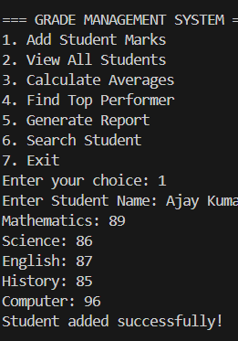

✅ Test Case 2 – Invalid Mark

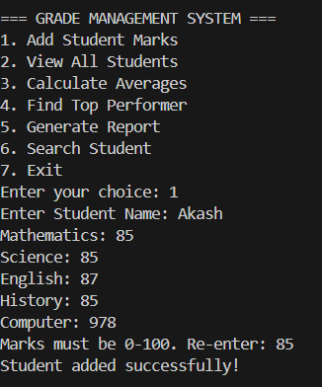

✅ Test Case 3 – Search

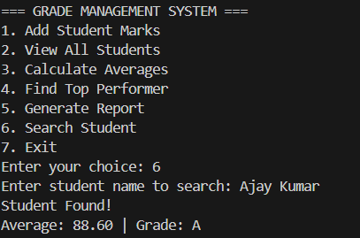

8️.Quality Standards Checklist
✔ Clear project objective
✔ Organized code structure
✔ Input validation included
✔ Grade calculation implemented
✔ Report generation implemented
✔ Search functionality included
✔ Top performer logic included
✔ Proper menu system

9️.Conclusion
The Grade Management System successfully demonstrates structured programming using arrays and modular methods in Java. It efficiently manages student academic records, performs analysis, and generates reports. The system can be further enhanced using ArrayList, file handling, GUI, or database integration.

